20.19: The total work that must be done is

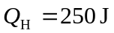 Find 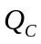 so can calculate work  done each cycle:
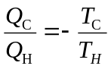
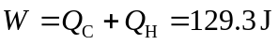
The number of cycles required is 